YAESU FT 817 and DRM (Digital Radio Mondiale)

By Andrea Borgnino IW0HK and Carlo de Marinis IW0HEI
email: a.borgnino@agora.it
http://www.mediasuk.org/iw0hk
(thanks to Andreas Weller, DF1PAW And Kord Wolff, DF5PW for inspiration)

Disclaimer: modifying your transceiver void warranty.
Proceed at your own risk !!

Remove the upper cover from the transceiver. Look first the optional CW or SSB Filter slot in the main unit. You must have this slot free (no optional filter) for using DRM on this radio.
The 455 KHz Signal for the DRM mixer can be easy taken from the first pin (from right) of J21 connector and connect the ground of cable to the second pin.
Look the following images:

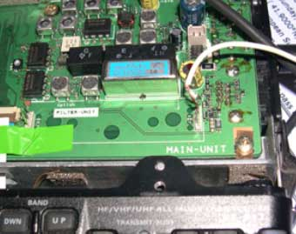
The filter slot in the main unit
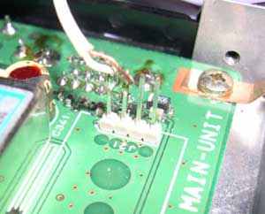
J21 Pins and cable for 455khz signal

Now put a capacitor (value 50 pf to 120 pf will be good) between the first right pin of J20 and the first right pin of J21 (this capacitor is not show in my photos).

Switch on the rig and enter in the Menu System (press and hold the [F] key for on second) and choose Menu Item 38 [OP FILTER] setting mode CW. You can activate now the DRM reception using the function NAR of the operation menu and setting CW MODE.

I have tested this radio with a 455khz/12Khz Sat Service mixer and GNU Dream Software ver. 1.07 . DRM reception it’s perfect on medium and short wave.

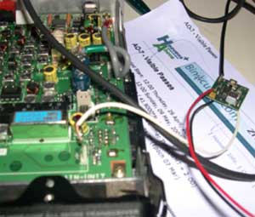
FT 817 and the little Sat Service DRM Mixer

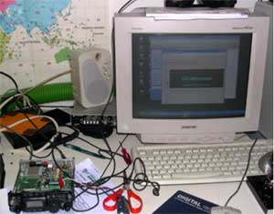
Listening DW-Radio in DRM on 7125 khz with Ft-817 and Dream Software Ver. 1.07

