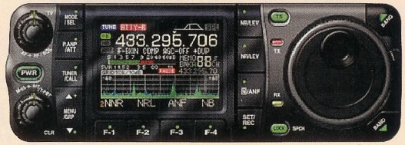

ICOM IC-7000

Source: Megahertz Magazine, No. 263, Feb. 2005, p. 10.
It is under this designation that the successor to the IC-706MKIIG has been announced. We should know some more soon, since it will be available in the second quarter of 2005, according to information supplied by ICOM France.
The sketch, derived from CAD, shows a rather unusual attractiveness; if anything, it is somewhat revolutionary! Here we see for the first time the colour screen as adapted to a multi-band transceiver with detachable control head.
Here are the main characteristics as announced:
- The rig will be equipped with IF-DSP, which will control Twin PBT and Noise Reduction (NR) features, an inheritance from more sophisticated models (IC-756ProIII, IC-7400 etc.) The IC-7000 will not require or accept optional filters.
- Approx. 35W UHF power output.
- A 5 cm TFT colour screen.
- Very high frequency stability (0.5 ppm).
- 508 memory channels.
- Multi-function scanning.
- Built-in voice recorder and clock.
- Completely updated control-panel design, approaching that of "base" stations.
- Free-rotating or detented tuning control.
- Case 20 mm shorter than IC-706.
- Generously-sized, backlit keys.
- 10-key hand microphone supplied.
- Detachable control head.
The other characteristics are those of the IC-706MKIIG.
It goes without saying that we are waiting with eager anticipation! Perhaps this new radio will be your travelling companion for your next vacation trip?
Original copyright © 2005, Megahertz Magazine. Translated by A. Farson VA7OJ/AB4OJ. Last updated:.
Top of Form
Bottom of Form

