IC_7000 Export No 8 to receive PAL TV in South Africa and TX mod

  Contact author:
  Gary Immelman ZS6YI
Print Modifying the Icom IC 7000 Export version No 8 to receive PAL TV in South Africa
and to open up the TX frequency range.
Gary Immelman ZS6YI
In South Africa the TV audio frequency is different to that used in other parts of the world.
We use 6 MHz instead of 5.5 MHz as used in the Icom IC 7000 export #8.
The ceramic trap filters have to be replaced. They are situated at the bottom of the Main Board.
This board needs to be completely taken out of the radio then obviously replaced once the new
filters have been fitted.
The shift register diodes need to be changed in order to open up the frequency range and
enable the television tuner. A number of diodes are removed and one diode installed where
no diode originally existed.

METHOD
- Remove the top cover of the radio and unclip the speaker plug.
- Remove the CPU/Logic unit. (Silver box)
- Remove the DDS unit.
- Remove all coaxial plugs and ribbon cables from the board. Be extremely careful when
removing the two ribbon cables at the front of the radio as they can be pulled out of the PA
unit. It is extremely difficult to reinsert them into the PA unit.
- Remove the spring clip at the back of the Main board holding IC 2602 to the chassis.
- Remove the Main Unit - This is the unit to be modified.
- Remove the two SMD ceramic trap filters situated underneath the board as seen from
the top view.
- Replace old filters with 6 MHz ceramic trap filters obtainable from any TV repair shop.
Cost R8.00 each.
- Remove shift register diodes. Fit one diode at right hand side of the board as viewed
from the front of the radio looking towards the back, orientating it with the cathode to the left.
- Plug in the two ribbon cables from the DDS unit into the Main board before fitting the
Main board to the chassis.
- Replace all screws and tighten.
- Plug in all the cables, re-fit the CPU/Logic unit etc.
- Replace the top cover. Don't forget to plug in the speaker.
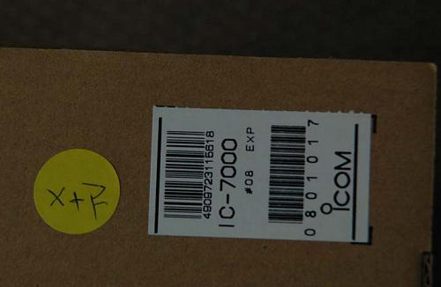
Label on IC 7000 box #8 Export model
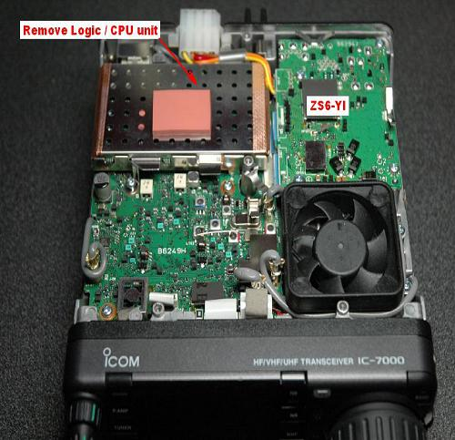
Remove the CPU/Logic unit
Step 1
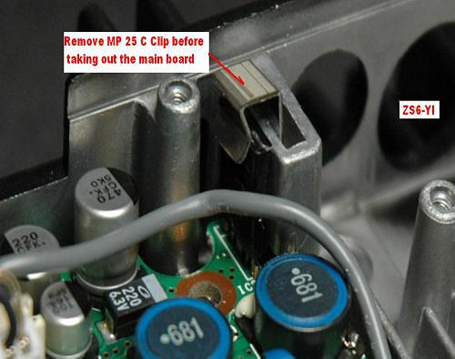
Unclip the spring clip situated at the back mid right hand side of the radio
Step 2
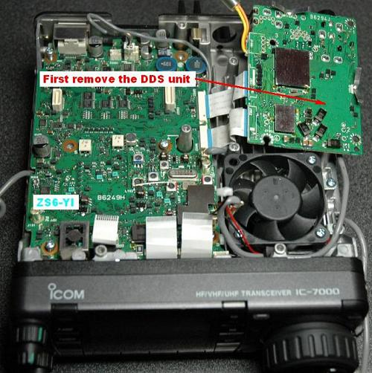
Remove the DDR unit first then the main board
Step 3
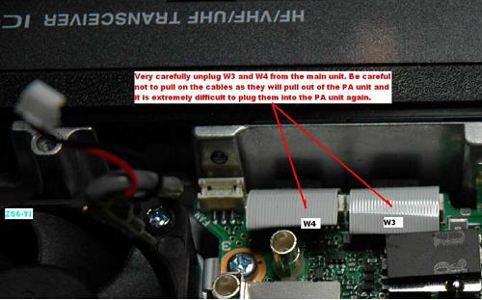
Very carefully unplug ribbon cables. Don't pull on them!
Step 4
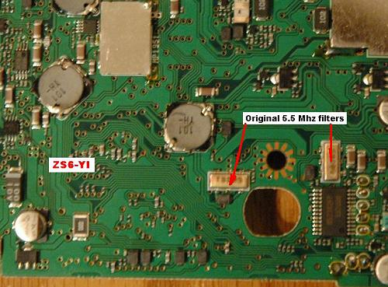
Original 5.5 MHz SMD ceramic filters
Step 5
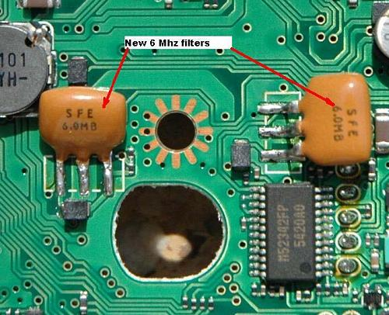
New 6 MHz Ceramic Trap Filters
Step 6
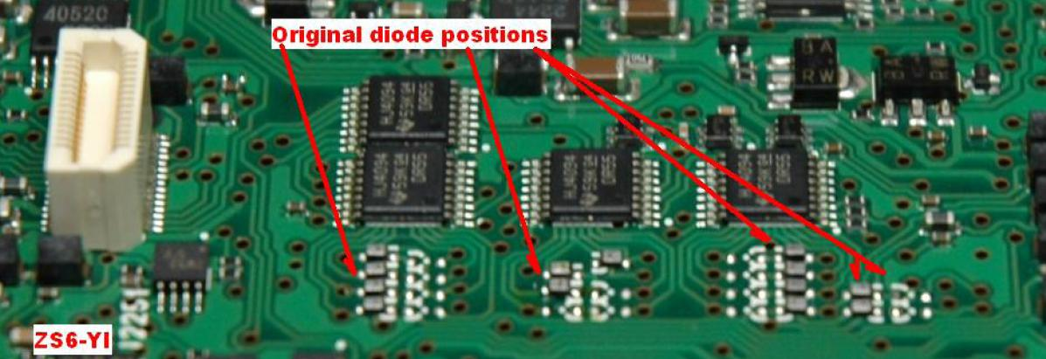
Original Diode Positions
Step 7
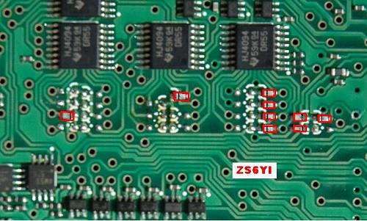
New Diode positions
Step 8

OPERATION
Connect the power supply to the radio and couple a TV antenna terminated in a PL259 plug to the VHF antenna socket of the radio. (Right hand side of the radio as seen from the front looking towards the back).
When you switch the power on a warning message will appear on the blue screen. Press Yes that you acknowledge the warning.
The radio reverts to the original frequency you had the radio on before embarking on the modification.
To activate the TV receiver push and hold in the set button (Volume control situated at the top left hand side of the radio). If the TV receiver does not come on, push the set button (volume control) once again. The TV receiver will now come on.
It is advisable to switch on the preamplifier.
By using the Band up and down buttons you can change TV channels, select a channel.
To change the frequency press the ADJ button and tune in the station using your VFO knob. You can do quick frequency movements by pressing the TS button.
Once you have found a station (audio only) press SET at the bottom of the screen. You should now see a picture.
You can now fine tune the picture by rotating the VFO knob.
Once everything is tuned perfectly press the volume control (set) button to store the station into the channel number previously selected.

ACKNOWLEGEMENTS
I wish to thank my son Quintin ZS6IY for his help with the soldering of these minute components using his hot air soldering station (surface device soldering station).
OM Eddie Leu ZL3TEL for his assistance and photos of the New Zealand expanded frequency range.
OM Paul Hayden VK4ZBV for information on the Australian and South African audio frequencies.
Finally OM Ken G3SDW who initially discussed changing the sound filters with me. His email inspired me to get cracking.

In Conclusion
For those South African Hams who have purchased the American model. I am working on a modification to change the NTSC system to PAL. It involves changing a number of parts on the main board. It won't be difficult but procuring the parts may be a challenge.
If I can get hold of the oscillator and coils I will do the modification then update everyone as to its success.
A PDF file of the modification can also be downloaded here. (893 Kb)
73 Gary Immelman ZS6YI

