IC-7000 Mods

Thanks to Steve, N5AC for his research and success in determining the mods below!

Disclaimer: No liability is assumed for the accuracy of this material or the consequences of its use. Use of this information is intended to be educational and is at your own risk. Modifications to your radio may void its warrantee and may be illegal in your country. It is your responsibility to check and follow the laws of your country in regards to this information. In NO case should the TV function of this unit be watched by the driver while a vehicle is in motion.

TVRO:

1. Remove CPU/DSP unit by unscrewing three silver screws holding it down
(the silver box on the top of the radio with copper taped sides) and pull
up.
2. Locate four shift registers and bank of diodes - shift registers are
4094's. There are two next to each other and then a couple more. We'll
call the two stacked the "left" ones
3. The "middle" shift register if looking from the front of the radio
is the target.
4. Locate bank of SMT diodes (silver with "K" on top on one side) in
front of the target shift register. They are in two columns, "left" and
"right"
5. Unsolder one side of the second diode from the front on the left and
lift up one side (or remove, slip to the side, whatever turns you on)
MARS:

OK - here's an out-of-band mod that does TX from 0-54, 118-173, 400-470.
1. Remove CPU/DSP unit by unscrewing three silver screws holding it down
(the silver box on the top of the radio with copper taped sides) and pull
up.
2. Locate four shift registers and bank of diodes - shift registers are
4094's. There are two next to each other and then a couple more. We'll
call the two stacked the "left" ones
3. The "left" shift register if looking from the front of the radio is
the target.
4. Locate bank of SMT diodes (silver with "K" on top on one side) in
front of the target shift register. They are in two columns, "left" and
"right"
5. Unsolder one side of the second diode from the front on the left and
lift up one side (or remove, slip to the side, whatever turns you on)

NOTE: The Automatic Repeater Shift on 2 meters and 440 is not affected by this mod! The “Band Edge Beep”, on the other hand, does not function.

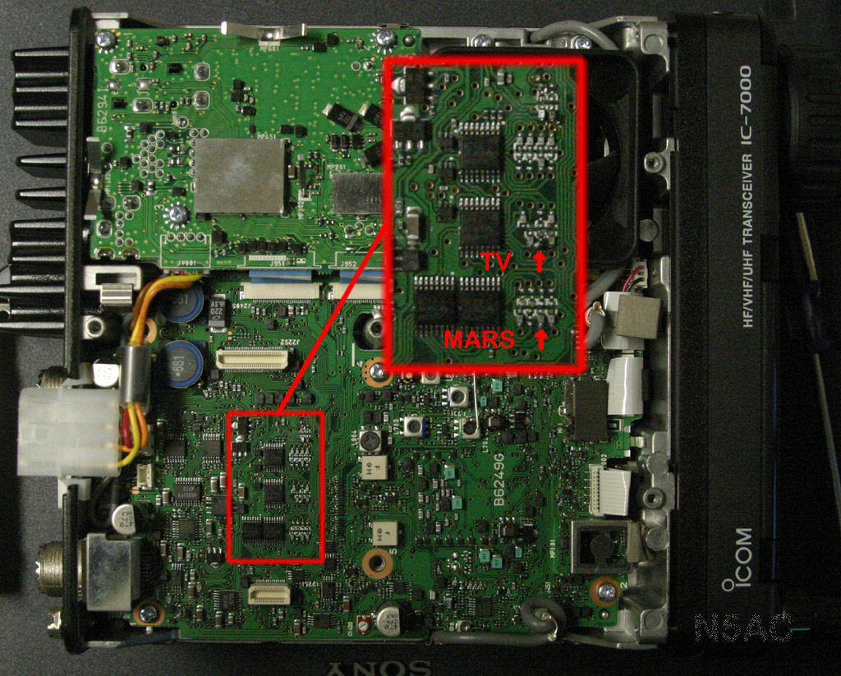

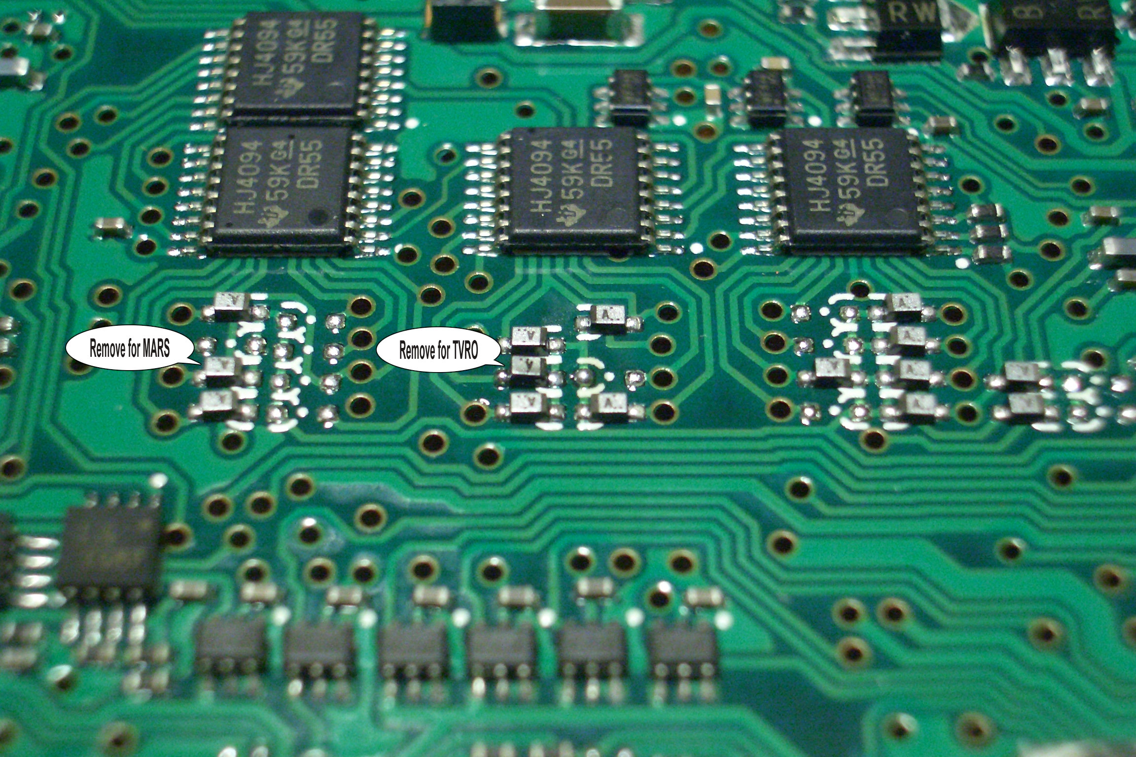
After modification, TV channels 2-13 are available (USA) in NTSC format

-Push and hold [AF(set)] for one second to turn TV mode ON and OFF

-Rotate [M-ch] (inner control) to select the desired TV Channel
-The Band keys to the far right of the radio also change TV channels
-There will be a popup showing the TV channel (This can be turned off in set mode)

-The preamp and attenuator functions are functional in TV mode and each channel can store the preamp/attenuator on/off functions independently
-There will be a popup showing the ATT/P.AMP status (This can be turned off in set mode)

-Rotate [AF] for a suitable volume level.

