

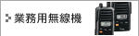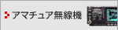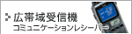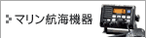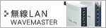 |  | Adopting IF step DSP for the first time in this class  マルチバンダー which loads the digital function of advancement  The succession model of IC-706MKIIG which is the long cellar machine is born, more and more. As this class IFDSP is adopted for the first time, basic efficiency and the digital IF filter and the digital twin PBT who are approached to IC-756PROIII®, manual notch filter - digital function of the advancement which is begun is actualized. Furthermore, besides the fact that the design characteristic due to flash surface conversion was overtaken, it has improved markedly by equipping eight keys which can be accessed direct in 2.5 inch TFT liquid crystal and the necessary function which are superior in visibility, regarding operativity.  *Actualizing the improvement and multi-functionality of throughput by the fact that DSP IC is equipped 2  *The advanced digital IF filter, loading digital® twin PBT  *The manual notch filter which has two notched points -  *Equipping 2.5 inch TFT liquid crystal which conveys colorful information clearly  *The multi-function microphone which can operate colorful function with labor assistant < HM-151 > attachment  *The television reception function which can enjoy TV program with ease plus  Main merit  ------------------------------------------------------------------------------------------------------------------------  *DSP IC 2 loading  The digital IF filter, manual notch filter -, actualizing the digital® functional group of the advancement which begins digital twin PBT, in this class. By the fact that DSP IC is loaded 2, at high speed processing of high accuracy is made possible.  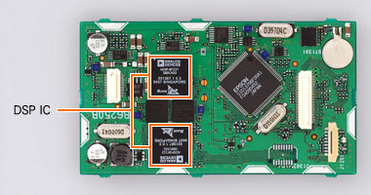  *Processing inside the AGC loop due to DSP  The digital IF filter and manual notch filter - etc., by the fact that it processes inside the AGC loop due to DSP, banishing the blocking by the powerful signal of contiguity frequency outside the filter fundamentally. As a result, squeezing the mark to the intended signal, it became possible, to operate AGC, reached the point where it can evade sensitivity oppressing which is not intended. Furthermore, with each mode, it can select the time constant of AGC from 3 types of FAST/MID/SLOW. (Also AGC-OFF is possible)  *Filter Supreme Headquarters Allied Powers, europe selection possible digital IF filter  Loading the digital IF filter of 41 types which correspond to all band. Supreme Headquarters Allied Powers, europe of the filter 2 types which become independent respectively with SSB and CW (sharp/the software) from can be selected according to, all circumstances such as operational band and band condition. Furthermore, while really receiving the signal, it is possible to change.  *2 point manual notch filters -  The manual notch filter which has two notched points which are proud of above attenuation 70dB - new development. Former automatic notch filter - with also combined use being possible, while cutting two beats simultaneously with the manual notch, it is possible to operate the automatic notch.  *The digital twin PBT by DSP filtering®  When receiving the radio interference simultaneously from the top and bottom, loading the digital twin PBT who shows® power. As for passing bandwidth it is possible to set freely with 50Hz step. When receiving the radio interference from one side of the top and bottom, the effective radio interference removal which responds to circumstance the IF shift which is effective by using properly, becomes possible.  *The noise reduction which variable it is possible oppressing level  It makes the signal surface which relatively has been buried to noise by being attenuated offensive noise. Oppressing level can do variable at 16 stages. In addition, showing power even in data communication not only speech communication. With RTTY it can make the illegal character lighten.  *Advanced noise blanker -  The effective noise blanker to pulse characteristic noise - it loads. Pulse width and variable of level is possible. Because as for adjustment with the fact that you adjust to 0 - 100 stages on the screen the る, it is possible effectively to remove noise.  *Digital function corresponds to HF - UHF  Digital twin PBT® and 2 point notch filters - the colorful digital functional group which is begun operates to the HF - 430MHz band. Because of this, high level operation becomes possible in all bands.  *Achieving the high power conversion of the 430MHz band  As for the HF 50MHz band 100W, as for the 144MHz band actualizing the Takaide power of 50W. Power it raises in 35W regarding the 430MHz band.  *The key arrangement which seriously considered operativity  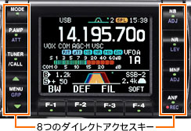Arranging eight buttons in both sides of LCD display. Noise reduction and notch filter - etc. to it becomes possible to access direct, operativity rapidly has improved. In addition, functional ON/OFF be able to do the function key under LCD displaying, shortly with pushing, setting of numerical value is possible with the long pushing. Furthermore, summary indication of setting item (maximum of 4 items), because selection of the item with up-down is possible, it calls necessary function speedily, it is possible to set without being perplexed.  *Compact body  While covering the HF/50/144/430MHz band with all mode, assuring multi-functionality simultaneously, 167 (W) the ×58 (H) the ×180 (D) it actualizes mm compact size.  *2.5 inch TFT color liquid crystal  With the adoption of 2.5 inch TFT color liquid crystal, it reached the point where colorful information can be grasped quickly. Furthermore, as for indication 3 types<ネガタイプ><ポジタイプ><カラータイプ>Besides the fact that it is possible, to set the empty, according to taste and operational environment enlargement indication of frequency and selection of the font it is possible (from 2 types).  *The band scope which has two modes  Power is shown in grasp of the band condition and discovery of on air bureau. Locking center mode and the top and the bottom which of the scope sweep the range which sets reception frequency on the center, it has the FIX mode which you watch.  *Multiple meter indication  Transmission coming out mosquito level, SWR, ALC level and the multiple meter which indicates the compression state and the like at the time of speech processor use, in simultaneously are equipped.  *The RF speech compressor by DSP  Increasing compression level, it is the RF speech compressor which the strain does not occur in sound, had ideal quality. Because the sound quality whose quality is high in all compression levels can be actualized, it can utilize widely from participation to pile rise to ラグチ…ー.  *Transmission sound unrestrictedly setting possibility  As for zone setting of the transmission wave, in the limits the setting of 2500Hz, 2700Hz and 2900Hz is possible low with 100Hz, 300Hz, 500Hz and high pass. It is low, it can pre-set 3 types combining the limits and high pass with freedom.  *Multi-function microphone < HM-151 > attachment  As for the microphone of the attachment which has 10 キーパッド, as for rise of frequency/down and change of mode of course, the call of the memory channel, it corresponds to also the triple band stacking register. Just push the band switch of the microphone, optimum operational frequency and it is possible to move to mode smoothly. In addition, two programmable keys which can allot the function which is used well, nighttime and it equips also the key illuminational function which can be operated comfortably even at inside of car of car.  *IC recorder which can record communication contents  IC recorder whose sound recording maximum of 20 minutes is possible is loaded. It is possible to retain important contents, to verify contents after the communication ending. In addition, because memory to do four definite form sentences it is possible as a one for transmission, it can lighten the burden of the operator in the contest and the like.  *Television reception (1ch - 12ch analog ground wave) function  Because the television tuner is built in, it can look at TV in the interval and the like of use.  *Front panel separate installation is made easy  The front panel separate system which corresponds to the installation to the inside of car of car where, restriction such as installation place and the space is many softly is adopted. In addition, if the separate cable of option is used, because it can receive the substance to the trunk, furthermore degree of freedom of installation increases.  *Other functions  -Click change type dial  -SWR graphical representation function  -CW full break-in correspondence  -CW reception reverse function  -CW reception pitch adjustment function (sidetone gearing)  -FM tone squelch function  -Katakana input correspondence and 503ch memory (the band edge and the call channel for scan are included) the &5 the memory bank  -Voice synthesizer < frequency speech function >  -Duplex function automatic repeater function  -Emergency traffic communication setting frequency (4630kHz) correspondence  -Transmission monitoring capability  -DTMF monitor  -Quick band change  -The smallest frequency analysis talent 1Hz  -RIT/VOX  -RF/SQL knob  -Large-sized speaker  -Thermoconcrete trawl silent cooling fan  -Automatic TS function  -Band stacking register  -Noise squelch &S meter squelch (even with wide FM enabled)  -Reception pre-amp  -Dial lock  -アッテネータ  -CI-V correspondence  Option  ------------------------------------------------------------------------------------------------------------------------  Main rating  ------------------------------------------------------------------------------------------------------------------------  * Rating JAIA (the Japanese amateur radio equipment manufacturer's association) depends on measurement method.  * As for rated specification appearance and the like for improving there are times when it modifies without notice.  * The eye COM corporation, eye COM, ICOM logograph, PBT is registered trade mark of the eye COM corporation.
  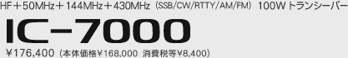
  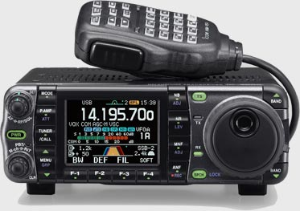
  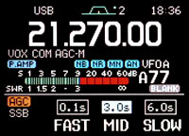
  At the time of AGC designated several setting indicatory examples
  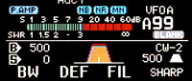
  Filter setting indicatory example
  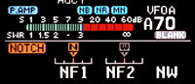
  Manual notch filter - setting indicatory example
  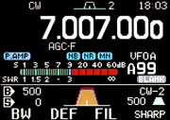  Negative type indicatory example |  | 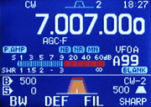  Color type indicatory example |  | 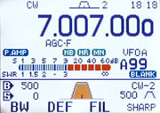  Positive type indicatory example
  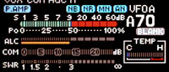
  Multiple meter indicatory example
   | 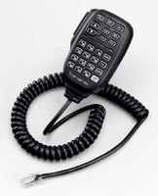  HM-151 |  | 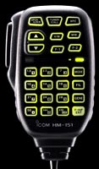  Key illumination
  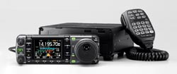
  At the time of separate
  AH-2b |  | : HF antenna element for load/base (for AH-4)
  AH-4 |  | : Outside installation type HF+50MHz automatic antenna tuner
  AT-180 |  | : HF+50MHz automatic antenna tuner
  CT-17 |  | : CI-V level converter unit
  HM-151 |  | : Remote control hand microphone (for modular type repair)
  IC-PW1 |  | : The HF all band +50MHz the 1kW linear amplifier (OPC-599 is needed)
  MB-62 |  | : The mobile bracket (as for the substance ま it is for AT-180)
  MB-65 |  | : Mount base (for MB-105)
  MB-105 |  | : Bracket for controller
  MB-106 |  | : Carrying handle
  OPC-589 |  | : Modular ⇒ 8 pin microphone connector conversion cable
  OPC-598 |  | : Long cable for AT-180 control (7m)
  OPC-599 |  | : 13 pin ⇒ 8 pins for ACC +7 pin conversion cable
  OPC-742 |  | : Adapter for AT-180 control cable
  OPC-1443 |  | : Front panel separate cable (3.5m)
  OPC-1444 |  | : Front panel separate cable (5m)
  SM-20 |  | : The rise/down switch equipped high-class stand microphone (OPC-589 is needed)
  SP-7 |  | : Small-sized desk-top speaker
  SP-10 |  | : Speaker outside mobile
  One  Carrying  SI  Way | Frequency range | Reception frequency  (Operating range)  30kHz - 146.000MHz,  430.000MHz - 440.000MHz  (Guarantee range)  0.5MHz - 29.995MHz,  50.000MHz - 54.000MHz,  144.000MHz - 146.000MHz,  430.000MHz - 440.000MHz  Transmission frequency  From 1.9MHz band all the amateur bands, and 4630kHz to 430MHz band
  One  Carrying  SI  Way | Radio wave type | A1A, A3E, J3E, F1B and F3E
  One  Carrying  SI  Way | The number of memory channels | 503ch (usually memory 495ch, call 2ch and the scan edge 6ch)
  One  Carrying  SI  Way | Antenna impedance | 50 Ω (imbalance)
  One  Carrying  SI  Way | Antenna terminal | SO-239×2 (for HF/50MHz band and for VHF/UHF band)
  One  Carrying  SI  Way | Power supply voltage | DC13.8V±15%
  One  Carrying  SI  Way | Category temperature range | -10 ℃ - +60 ℃
  One  Carrying  SI  Way | Frequency stability | Within ±0.5ppm (+0 ℃ - +50 ℃)
  One  Carrying  SI  Way | Consumed electric current (at the time of DC13.8V) | Reception expecting 1.3A  When receiving maximum 1.6A  When transmitting maximum 22A
  One  Carrying  SI  Way | External size (projection ones are excluded) | 167 (W) ×58 (H) ×180 (D) mm
  One  Carrying  SI  Way | Weight | Approximately 2.3kg
  Sending  Trust  Section | Transmission output
     | SSB/CW/RTTY/FM | AM
    1.9 - 50MHz band | 5W - 100W | 2W - 40W
    144MHz band | 5W - 50W | 2W - 20W
    430MHz band | 2W - 35W | 2W - 8W
  Sending  Trust  Section | Modulation technique | SSB numerical operation type equilibrium irregularity  FM numerical operation type frequency modulation  AM numerical operational type it is low electrical irregularity
  Sending  Trust  Section | スプリアス discharge strength | -50dB below (HF band)  -60dB below (50/144/430MHz band)
  Sending  Trust  Section | Carrier oppressing ratio | Above 50dB
  Sending  Trust  Section | Unnecessary sideband oppressing ratio | Above 50dB
  Receiving  Trust  Section | Reception system | SSB/CW/AM/FM: Triple superheterodyne system  WFM: Doubles - per heterodyne system
  Receiving  Trust  Section | IF | SSB/CW/AM/FM: 124.487MHz, 455kHz and 16.15kHz  WFM: 134.732MHz and 10.700MHz  TV: 58.75MHz (image)
  Receiving  Trust  Section | Reception sensitivity  At the time of pre-amp ON;  4-4.5MHz and 8-9MHz are excluded
     | SSB/CW/RTTY | AM | FM | WFM
    0.5 - 1.8MHz | - | +22dB μ | - | -
    1.8 - 29.9MHz | -16dB μ | +6dB μ | -6dB μ | -
    50 - 54MHz | -18dB μ | 0dB μ | -12dB μ | -
    76 - 108MHz | - | - | - | +20dB μ
    144 - 146MHz | -19dB μ | 0dB μ | -15dB μ | -
    430 - 440MHz | -19dB μ | +0dB μ | -15dB μ | -
  Receiving  Trust  Section | Selectivity | SSB (BW=2.4kHz): Below /-60dB /-6dB 3.9kHz above 2.4kHz  CW (BW=500Hz): Below /-60dB /-6dB 900Hz above 500Hz  RTTY (BW=350Hz): Below /-60dB /-6dB 650Hz above 360Hz  AM (BW=6kHz): Below /-60dB /-6dB 15kHz above 6.0kHz  FM (BW=15kHz): Below /-60dB /-6dB 20kHz above 12kHz
  Receiving  Trust  Section | スプリアス disturbance ratio | Above HF band 70dB  Above 50/144/440MHz band 65dB (the 144MHz IF point is excluded)
  Receiving  Trust  Section | It is low frequency output | Above 2.0W (13.8V, 8 Ω, at the time of 10% strain)
  Receiving  Trust  Section | It is low frequency load impedance | 8 Ω

176,400.00 JPY
Japan Yen = 1,588.35 USD
United States Dollars

