Icom Radio CI-V Cables
Here is what I built a few years ago (like 14 !) to control my R-7000 and the IC-271/471.
I don't have any of those radios anymore, but saved the cable interface --
and it works fine with the 2720H.

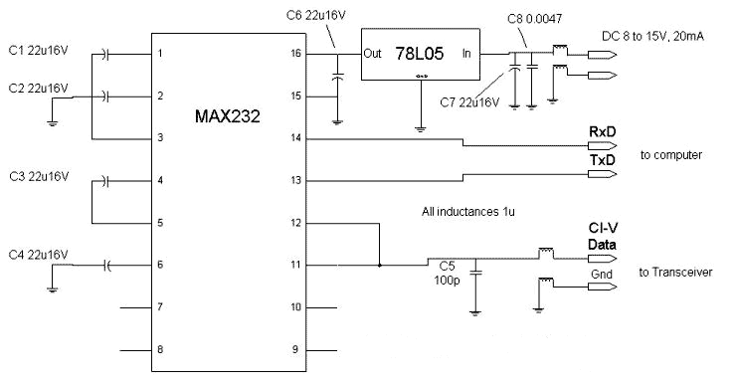
To be honest, I was lazy and DIDN'T put in the inductors nor the C7, C8, and C5 bypass caps.
C1,C2,C3,C4 and C6, the MAX232 is all you need -- and all i used.
It works cheap and simple
in fact you can get the MAX232 chip free by asking for a sample from the MAXIM site!
(Don't tell them I sent you)

A 'quick and dirty' interface that doesn't require an external power supply
and one that you can mash into an RS232 connector hood (like Icom sells).
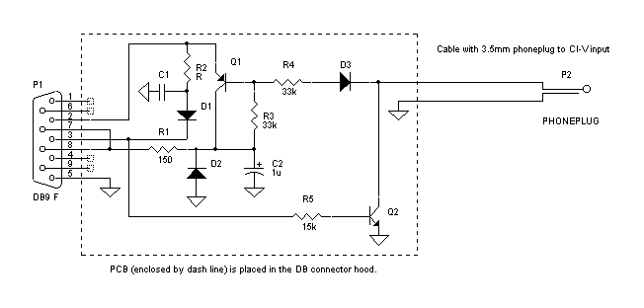
Alexander from Russia writes:
Concerning schematic for CI-V adapter. I drew down it from real pcb so I specified part value for readable components only. They all are smd.
C1 - ceramic (looks strange but it's true),
R5 - at least 0.5W
Q1 and Q2 I guess can be any switch transistors.
I checked this adapter with CI-V Explorer software, everything's ok.

2720 Navigation links

