OPC-478 Cable: programming for IC-F10/F20/M10/F1010/F2010/T7A/T8A/ R10/V8000/M2A/M1V/M402/M402S/M602

===================================================

OPC-478U USB Cable for Radio to PC Connection New!

Icom's USB Cable for Radio to PC Connection New!

Icom's New OPC-478U allows USB connection from Radio to Computer. For R3 and R5 receivers only.

Item Number: OPC-478U Quantity:

Price: $58.00 http://www.leeselect.com/shopping/pricelist.asp?prid=510

===================================================

R3-OPC478 R3 PC Serial Cable

===================================================

OPC-478 -- Serial Programming/Cloning Cable PC to Radio IC-R2, IC-R3, IC-R10, IC-R75, IC-R5, IC-2100H, IC-V8000, IC-2720H, IC-2800H, IC-T90A, IC-T2H, IC-T7H, IC-T81A, IC-V8A, and IC-W32A.

===================================================

ICOM - OPC478 - CLONING CABLE PC - RADIO FOR F11/F21/F3/F4/F3GS

ICOM

Model OPC478

CLONING CABLE PC - RADIO FOR F11/F21/F3/F4/F3GS

===================================================

To: <writelog@contesting.com>

Subject: [WriteLog] RE: WriteLog digest, Vol 1 #55 - 11 msgs

From: don@hfradio.com (Don Melcher)

Date: Thu, 13 Sep 2001 11:44:15 -0700

Interesting - that means the Yaesu cable is the SAME as the Icom OPC478 the programming cable used for the Icom ham/marine/landmobile radios - when it is used to program (or control) the HF radios, it must have the stereo to mono adapter used - the data line on the cable is on the "ring" of the stereo plug, and for the HF radios, the data needs to be on the tip. I have been using OPC478 for several years as a level converter - but the retail price is $45.

Don -- W6ZO

Message: 1

To: <writelog@contesting.com>

Date: Wed, 12 Sep 2001 14:21:09 -0400

To: WriteLog@contesting.com

From: Jerry Flanders <jflanders2@home.com>

Cc: icom@qth.net, ICOM706@yahoogroups.com

Subject: [WriteLog] Yaesu's ADMS-1D cable substitutes for ICOM CT-17 CI-V box

I needed to control /read my new ICOM 756PRO from WriteLog, and have been able to get the above cable working between the standard serial port of my computer and the input jack on the radio by only adding a Radio Shack 274-368 (1/8 inch stereo plug to 1/8 inch mono jack - $1.99).

With the RS adapter plug, the cable functions as if it were the CT-17, except that it only has one radio connector instead of the CT-17's 4.

Details: The ADMS-1D is a cheapie package (I paid $30 new 2 years ago) from Yaesu which contains software for programming some of the Yaesu radios (including my VX-1R) along with a cable to connect from the computer to the radio. The main cable includes an extension/adapter cable to allow the package to work with Yaesu radios having 4-conductor mini earphone/data sockets as well as 3 conductor ones. In addition, the cable includes a bi-directional level translator inside the DB-9 which converts to/from TTL levels.

Before trying with the radio, I plugged the cable into the serial port and read the cable's signal levels with a VOM to verify that the signal was on the center ring of the 3-pin plug and the common was on the base, and verified that the tip was not connected to anything. Opening up the db-9 verifies that only two wires are used.

The Radio Shack adapter plug is intended to convert stereo phones to mono by paralleling the ring and tip signals from the jack and connecting them to the tip of the mono plug. Just what I needed to "move" the signal to the tip of the adapter, where it plugs into the 756PRO.

It works, and there is no mod or change to the cable - I can still use it when needed with the VX-1R radio just by unplugging the cable from the RS adapter plug and inserting it into the 4-conductor extension/adapter cable.

Been going several days now with the 756PRO - no problems.

Jerry W4UK ===================================================

At 11:44 AM 9/13/2001 -0700, you wrote:

>Interesting - that means the Yaesu cable is the SAME as the Icom OPC478 -the programming cable used for the Icom ham/marine/landmobile radios – when it is used to program (or control) the HF radios, it must have the stereo to mono adapter used - the data line on the cable is on the "ring" of the stereo plug, and for the HF radios, the data needs to be on the tip. I have been using OPC478 for several years as a level converter - but the retail price is $45.

>Don -- W6ZO

I think RT systems in Alabama originated the Yaesu cable kits. At the RT systems web site http://rtsars.com/ ICOM, YAESU, and "other cables" pages, they describe packages with cables for several radios. You can see which cable is common to several radios, and so I believe we could infer inter-radio compatibility from these listings. As I read it, the cable that

came with my VX-1R programming package is also included in 9 out of the 11 ICOM radios listed, so there appears to be WIDE interchangeability. I just discovered that my IC-2100 mobile is covered, if I can find the software.

On their "Other cables" page, they list a cable specifically designed to do what I was after - the "RTS-01 Computer Interface cable for Icom HF Radios $35.00" I didn't know they sold this RTS-01 - it would probably be the way to go unless you already had the cable like I did.

Jerry W4UK

SNIP

===================================================

http://24.237.160.4/files/HamRadio/IcomR10/opc478.htm

For reasons unknown, Icom neglected to mention that their OPC-478 Cloning Cable is not the only way to program the IC-R10. A standard CI-V level converter will operate with the cloning software if it is plugged into the CI-V port.

PC Cloning:

Icom's OPC-478 "PC cloning cable" is nothing more than a CI-V level converter with different pin outs.

The CSR-10 Cloning software has encrypted data files, but the data that is streamed to and from the radio during cloning operations is standard CI-V formatted data.

1) Cloning is possible with the OPC-478 plugged into the CI-V jack if the pins are swapped.

2) Cloning is possible with a standard CI-V level converter into the CI-V port on the IC-R10.

3) Cloning can take place on the speaker jack with a standard CI-V level converter and a pin adaptor.

Software Control:

1) OPC-478 functions with CI-V software if plugged into the speaker jack.

2) OPC-478 does not function when plugged into the CI-V jack.

Reason: Icom swapped the pin outs on their stereo plugs.

CI-V Interface:

1) The standard CI-V connector is a mono connector, but is stereo inside the IC-R10.

2) Standard CI-V level converter functions with CI-V software if plugged into the CI-V jack. (normal operation)

3) Standard CI-V level converter functions with CI-V software if pins are swapped and plugged into the speaker jack.

4) The OPC-478 functions in the CI-V jack if pins are swapped.

===================================================

Jun 21, 2004 eHAM KA3EAJ

Misc Icom OPC-478

9 pin serial programming cable for many Icom HTs. Will also work with 756PRO and PROII (and others?) using included 1/8" 3 to 2 conductor (stereo to mono) adapter. $35 shipped Priority Mail CONUS.

Phone: None entered Email: alphabet@verizon.net
IC-2720 – (from Pegasus Mail)
If you have a CI-V you can make a cable that takes the two conductor plug for the CI-V and add a 3 conductor (Better known as a Stereo plug) and connect the tip of the two conductor to the ring (center) of the stereo plug and the ground to ground on both plugs. Nothing gets connected to the tip of the stereo plug.

Bob, W3PT, just another one by two ham. :)
For cross band repeat you do the following:

1. Set up the left band for 2m and the right band for UHF.
2. Press the duplex, low, and set buttons together for 2 seconds.
3. To cancel cross band repeat, press set button for 2 seconds.

73, Dick AH6EZ/W9
===================================================

===================================================

Icom OPC-478 Connector
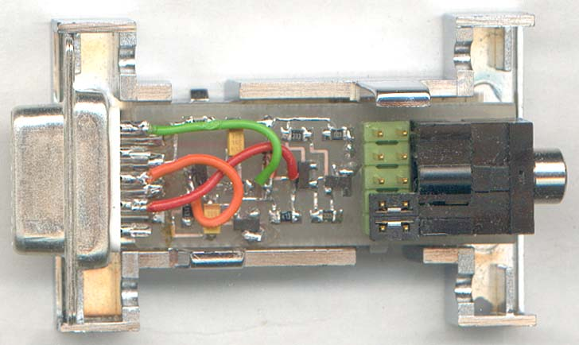
Info for this Connector was obtained from ICOM CI-V Hardware Page
Here are some images of the OPC478 connector someone is making for me.
Icom OPC-478 Interface.
The ICOM design for the OPC-478 interface is a simple transistor circuit used for cloning. The version by Chris VK3JEG http://uk.geocities.com/blakkekatte/hardware/opc-aus.jpg gives equivalents for the transistor and diode parts. That version is the one commonly found on the Internet. However the one from ICOM Japan's site http://uk.geocities.com/blakkekatte/hardware/opc478-japan.jpg has a few modifications. I have added the transistor and diode equivalences from VK3JEG's copy of the earlier version of the interface. WA0SXV http://www.wa0sxv.us/ci-v.html has some reservations that this design might not properly implement the RS-232 protocol.
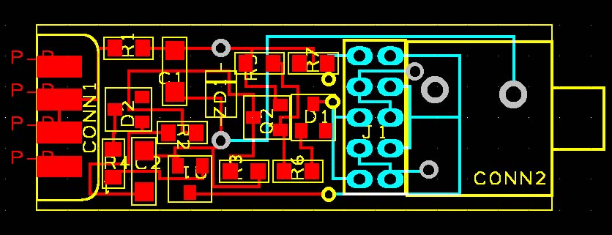
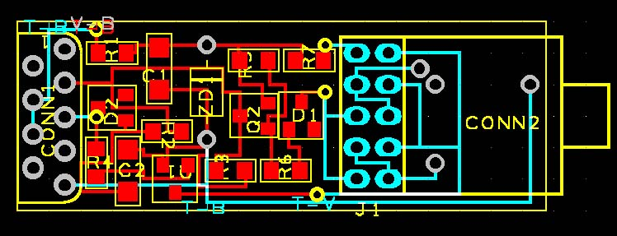
Posted by Gadget17 at 02:08 PM | Radio | Comments (2) | TrackBack

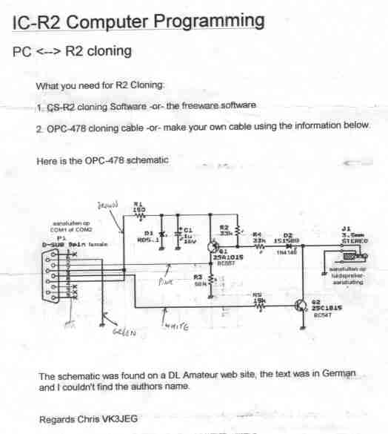

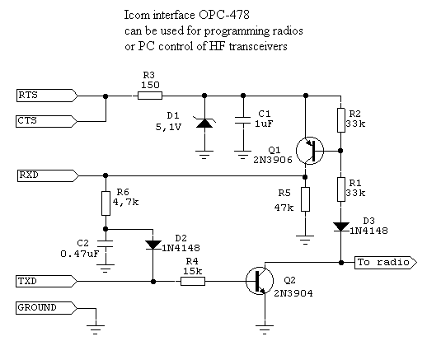

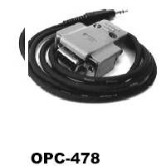

WAØSXV CI-V comments
I have designed and built a dual CI-V to RS232 interface (also capable of interfacing Yaesu) which measures 1½ inches square and runs from a single 9-volt wall transformer. Cost to construct, including new parts from Digi-Key is approximately 20 dollars excluding housing.
Why not use the CT-17? Well, I had one and it worked well. It adheres more to proper design than most of the ham designs and has extensive filtering. It uses the Maxim chip so it generates proper levels. I just wanted greater density and wanted to experiment.
Why dual?
Well, all the parts (except a resistor and three capacitors) were already there and therefore dual was essentially free. And I needed two converters at each of my stations and wanted to cut down the number of wall transformers and goodies dangling around the station.
In working on these projects, I spent some time looking at the CI-V bus and the resulting RS232 output for Icom remote control. Briefly, watch out if you're building your own CI-V interface. The QST February 1993 article on the interface is excellent, but several parts values are incorrect. In particular, using .01 µf bypass capacitors on the CI-V line results in unacceptably slow rise times at 9600 and 19200 baud. Icom uses 100 pf, which is fine in combination with the inductors they use. I'm currently using 470 pf. Whatever -- don't use the .01 µf on the CI-V bus. The RS232 lines seem to have enough power behind them to survive the .01 on them. In addition, the various 10 µf capacitors in that article can be either 1 µf or .1 µf depending on whether a normal or "A" version of the MAX232 chip is used.
Also of interest is the fact that, although they work, solutions involving the Icom OPC-478 cable and variants which use two or three transistors, use the serial interface power, and don't necessarily generate a negative voltage may actually violate the RS232 signal standards. As such, they may be vulnerable to numerous maladies including lack of noise tolerance and possible rate and content related errors. The MAX2xx line of chips actually include voltage doublers and generators of negative voltage. Only one of the discrete component designs I've seen actually does this. Compliance with these standards can be measured with a voltmeter or examined visually using an RS232 signal display. Another drawback of the port-powered interfaces is that they simply may not work on many laptops due to the lack of necessary control signals on the serial port.
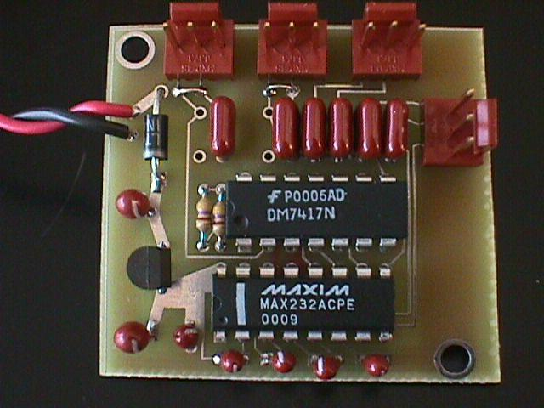
This is the dual CI-V/Yaesu board up close. Dimensions are 1½ x 1½. It is actually square. The dimensional distortions are the result of camera angle and a sloppy cutting job on my part. The unused pads are bypass capacitors not needed for the Icom interface. This particular picture was taken when the CI-V bypass capacitors were still .01 µf. These are the two capacitors to the upper left. These are now 470 pf. The entire assembly is powered by a 9v, 100 ma wall transformer available from Digi-Key for around 5 dollars.
A Surface Mount Technology (SMT) version of the dual board was designed, built, and tested. It measures 9/10 x 1 1/4. In fact, it is almost too small as it is difficult to attach all of the requisite wires to it.
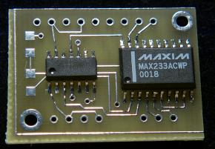  (Click on image to see larger) | This is the top view of the smt-based dual CI-V interface. It uses the Maxim 233 chip which minimizes component count -- there are four less tantalum capacitors. Unfortunately, at the same time it is significantly more expensive than the cheaper MAX232. A final production design would use the 232. The unused pads on the left are for 4.7k ohm pull-up resistors that some designs believe are necessary. I'm leaving them off until I can do some snooping with the scope!
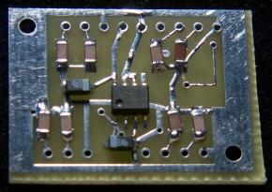  (Click on image to see larger) | This is the back and it shows why I've finally decided to not use smt unless absolutely necessary. Those ceramic chip capacitors are REALLY small. Disaster struck when the four on the right were inadvertently installed at right angles to the correct installation. Removal made a mess as I was, for some reason, trying to save the caps. Foolish move -- they are only twelve cents each! The board pad that I lifted in the process was somewhat more precious! Anyway -- it works and will be in a box so who cares about ugly?
I'm currently using the smt version to interface PTT and FSK for the primary radio in my SO2R layout in New Mexico. A bit of overkill but works great.
Construction information for the smt version is here.
By the way -- there is lots of good information on CI-V available at DF4OR's CI-V page.
BACK to WAØSXV home page.

Visitor number
de WAØSXV

  ICOM OPC-478U  USB Cable Kit  Order #0961 | Options


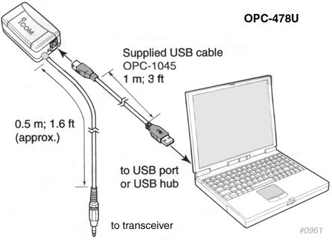
The ICOM OPC-478U is a special USB serial interface cable kit. The kit includes the OPC-478U interface box, the OPC-1045 USB cable and a driver diskette.
The OPC-478U can also be connected to a USB 2.0 port, however it will be transferring data in the USB 1.1 format. It is recommended that the OPC-478U not be used with a USB extension cable as data errors may result.
When using the OPC-478U for the first time, while Windows is running, the "New Hardware is found" dialog box appears. In this case, the USB driver installation is necessary. Icom provides these drivers on a 3.5 inch diskette that is included with your OPC-478U. It features drivers for: Windows XP, Windows 2000 and Windows 98/ME environments.

Send e-mail to dx@universal-radio.com
Copyright 2003, Universal Radio, Inc.

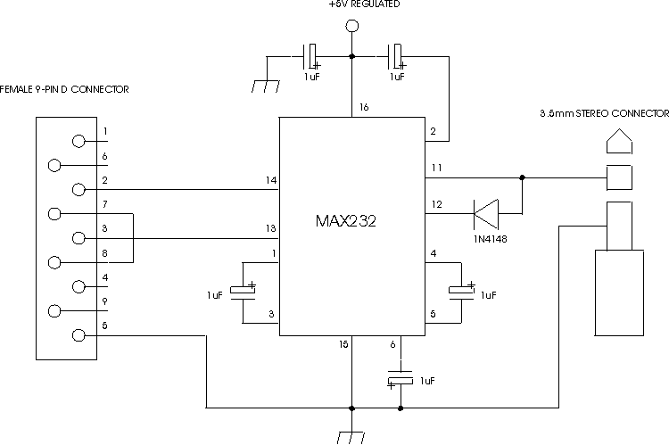
http://www.bmk.com.au/~cbfreq/

6 of 6 messages | Page 1 of 1

Need help in cloning a ICOM M710 | Reply
by 12J12 on June 18, 2004 | Mail this to a friend!
Hi!
I need help in cloning my 710.
I use the ex1726 soft and an OPC478 cable but it will not work ;-(
ERROR: clone error
any idea?
thx Michael

RE: need help in cloning a ICOM M710 | Reply
by N3EF on July 9, 2004 | Mail this to a friend!
Make sure the output to the stereo plug is connected to the "tip" and not the "ring" which I believe is the way this cable comes. For the 710, it must be connected to the "tip".
Eric N3EF

RE: need help in cloning a ICOM M710 | Reply
by WD0ETL on July 7, 2004 | Mail this to a friend!
Did you use set mode (hold down func and 1 and press power on) and change the following:
REMT--ID to a 1
REMT -- IF to PIN
73s
Earl J Quick

RE: need help in cloning a ICOM M710 | Reply
by KI4DLK on June 21, 2004 | Mail this to a friend!
What computer port does the cable connect to?

RE: need help in cloning a ICOM M710 | Reply
by 12J12 on June 22, 2004 | Mail this to a friend!
Hi!
I connect it with the RS232.
cu Michael

RE: need help in cloning a ICOM M710 | Reply
by WD0ETL on July 11, 2004 | Mail this to a friend!
That is the key to cloning the ICOM M710. The Cloning cable OPC-478 comes with a stereo jack but it will not work in the M710. You need to get a stereo to mono adapter (radio Shack possibly) and be sure that you use the side that converts the ring of the stereo to the tip of the mono. Plug the mono into the M710. Now be sure that the REMT --IF on the M710 is set to 'Pin'. Now power up the M710 THEN power up the PC. Serial ports are funny this way.
Now execute the program EX1726. Once started hit ESC Clone RS232 and select the proper Com port on the PC. Now you can click on PC < TR to get the current settings. Save these so you can always come back to them. Then have FUN>>>>>

http://www.butel.nl/icomr2/icom4.html

Icom R2 Information Plaza
The collection of Icom R2 information
Home | R2 Information | Mailinglist | Review | IF2 - Icom/Yaesu RS232 Interface | RS232 Schematics | Antenna Connector Info | Software | Pictures | Hidden Features | Schematics | Icom Websites
BuTel Software Home
New: Slim line interface for Icom/Yaesu

Here are a few schematics/links related to the Icom R2 interface you can build/buy. I've also included links to the sites were I found this info.
You need an interface to connect your R2 to a PC.
Please don't ask me details about these schematics. If you need info follow the links provided and contact the author.

Icom OPC478 Interface:

Original Icom Interface:
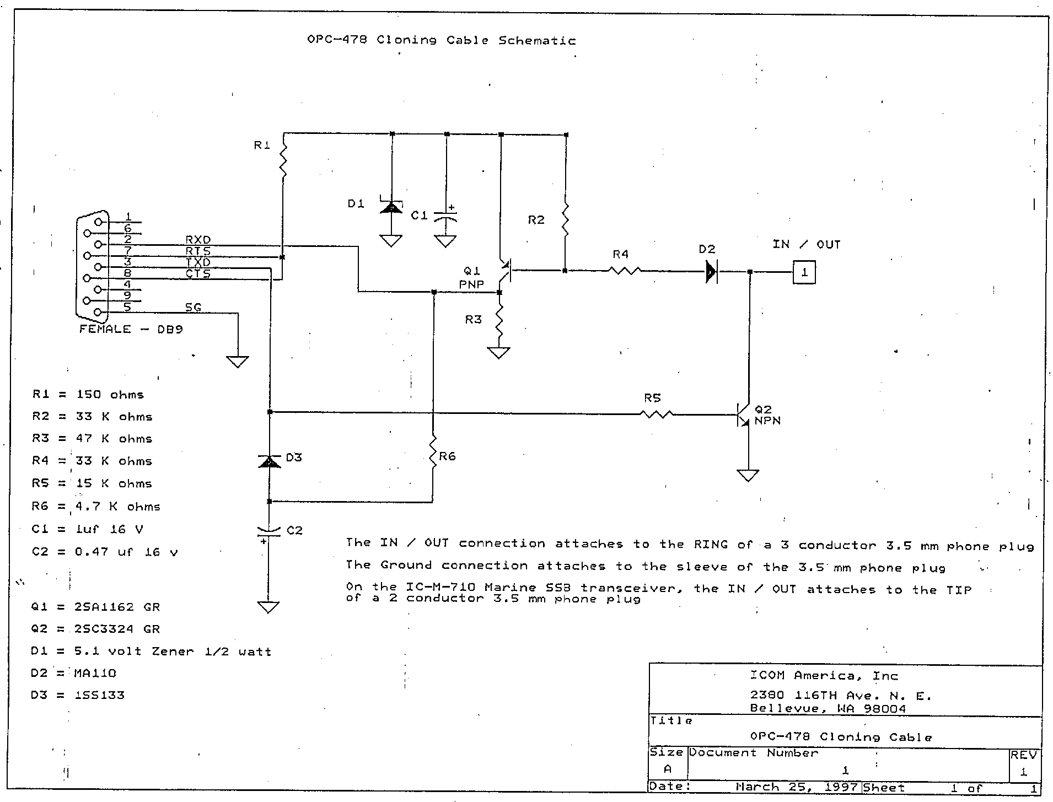

Interface with MAX232/233 chip.

Modified Icom Interface:
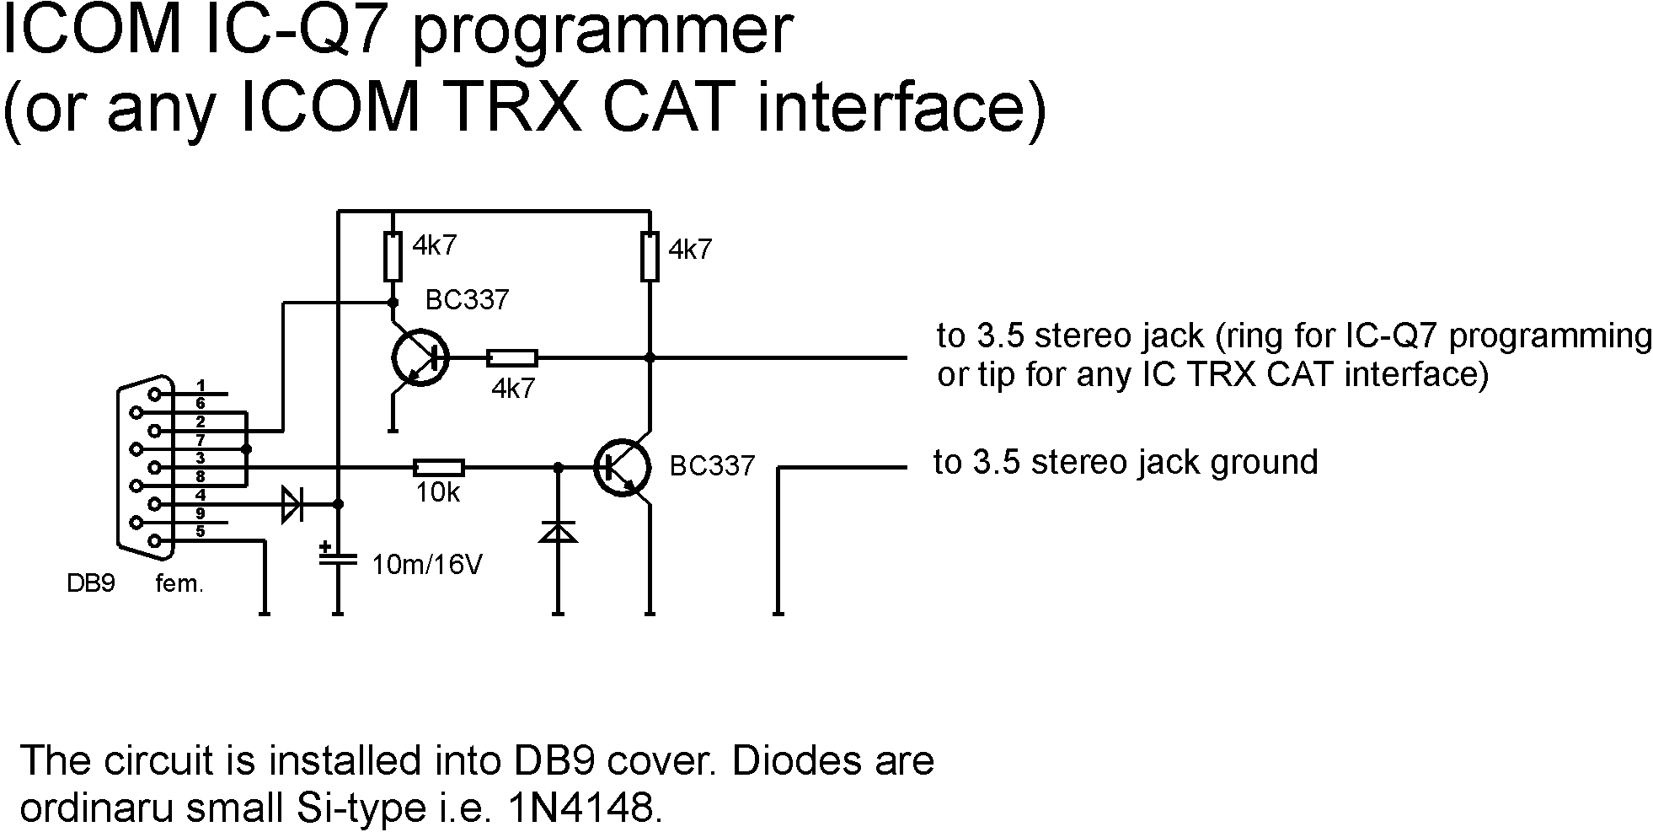

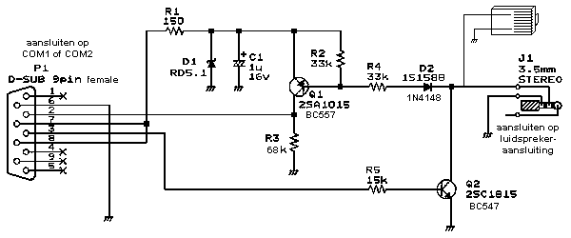

Icom OPC-478 build-it-yourself instructions
So far, all I have on this page is the actual Icom schematic.
Back to Bibber home
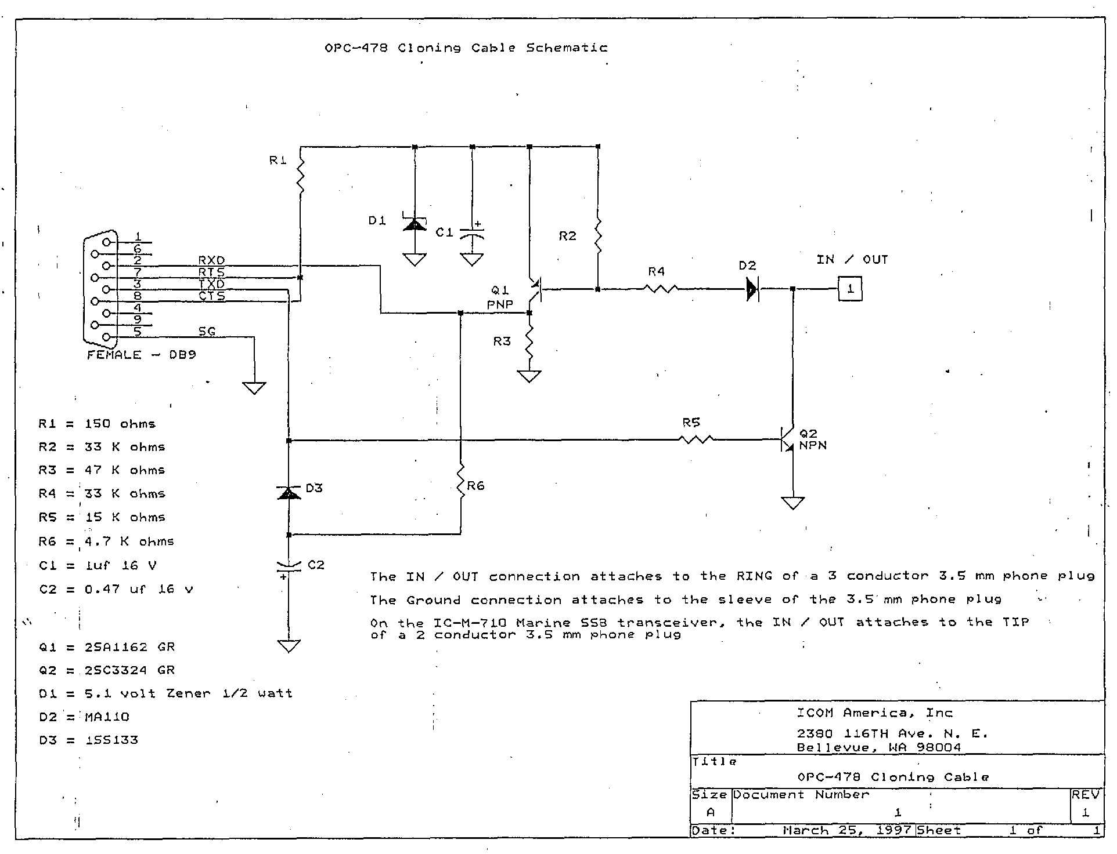

OPC-478

About OPC-478
As described on the Cloning page, the OPC-478 cable interconnects your IC-R10 and your PC. The OPC-478 cable has a 9-pin D-sub connector on one end, and a 3,5 mm jack plug on the other. The D-sub connector connects to a 9-pin serial port on your PC whereas the jack plug goes (originally) into the earphone socket of your IC-R10.
Inside the D-sub connector a small circuit is built that converts the TTL-level data on the IC-R10's side to the RS232C-levels on the PC's side. Please note that the 3,5 mm jack plug and the earphone socket are stereo versions. One channel is used for audio and one for cloning data transfer.
Technically, the OPC-478 is the same as the CT-17 level converter. All it does is transforming voltage levels. Since the OPC-478 is powered from the PC's serial port the number of Icom radio's that can be controlled is limited. The CT-17 on the other hand has an external power supply. Nevertheless, you can use your OPC-478 for controlling your unit using CI-V codes in exactly the same way as you would when using the CT-17. This requires one small modification, which is described elsewhere on this page.

Circuit
If you know how to handle a soldering iron, you can build your own OPC-478 interface (or CT-17 level converter). Here is the diagram:
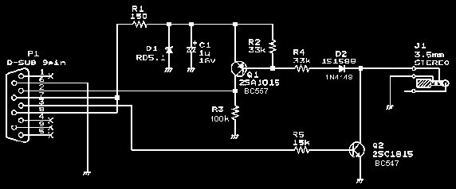
These components should all fit into the 9-pin D-sub connector.

Modification
ICOM has made a distinction between the connections of the earphone (cloning) socket on top of your unit and the CI-V connector on the side: the left and right channels are swapped. You can modify this in two ways:
- Open the 9-pin D-sub connector and swap the channel leads for L and R
- Build a small cable with a male and female (stereo!) plug and make sure L and R are swapped
This modification saves your earphone socket for the task it is intended for, and you can now connect your unit via the CI-V socket on the side and use either cloning software (like CS-R10) or controlling software (many shareware packages available on the Net).

Alternative
An email message was received from Keith Kirkwood (USA) in which he mentions an alternative to soldering yourself: available at Radio Shack, catalog number 274-368C is a "Headphone adapter". It adapts a 1.8" (3.5 mm) stereo plug to fit a 1.8" (3.5 mm) mono jack. Its price: US$ 2.09 incl. tax. Keith, thanks very much for your tip!
2 Component Cloning & CI-V Cable
This web site link (from SteveNet) has the information on how to build a 2 component cloning & CI-V cable for the IC-R10: http://stevenet.freehosting.net/icom/

Transceiver-to-Computer Interface Cables

LCU-3 cable: http://www.sarrio.com/sarrio/w1gee.html

Yaesu ADMS interface works with R10
Les Butler from MI. provided the following information:
The programming interface that comes with the Yaesu ADMS software for programming Yaesu Amateur radios works on the R-2 and R-10 Icoms. You'll need a mono adapter for the Icom but it works fine. The Icom R-2 works ok with either the 3-ring cord or two ring ADMS cord.
Last updated January 18, 2000
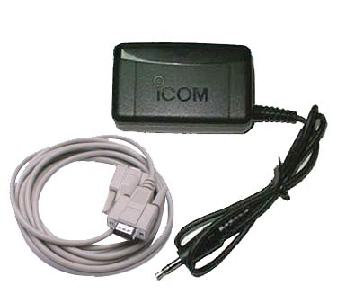

OPC-478 Serial Cloning Cable for ICOM Handhelds
from ICOM
For Icom IC-R5, ICOM IC-A22E and the ICOM IC-A3
The OPC-478 cable interconnects your IC-R5, your Icom IC-A22E and your Icom IC-A3 to your PC. The OPC-478 cable has a 9-pin D-sub connector on one end, and a 3,5 mm jack plug on the other. The D-sub connector connects to a 9-pin serial port on your PC whereas the jack plug goes (originally) into the earphone socket of your IC-R10. Inside the D-sub connector a small circuit is built that converts the TTL-level data on the IC-R10's side to the RS232C-levels on the PC's side.

- Please note that the 3,5 mm jack plug and the earphone socket are stereo versions. One channel is used for audio and one for cloning data transfer.

Icom Radio CI-V Cables
Here is what I built a few years ago (like 14!) to control my R-7000 and the IC-271/471.
I don't have any of those radios anymore, but saved the cable interface --
and it works fine with the 2720H.

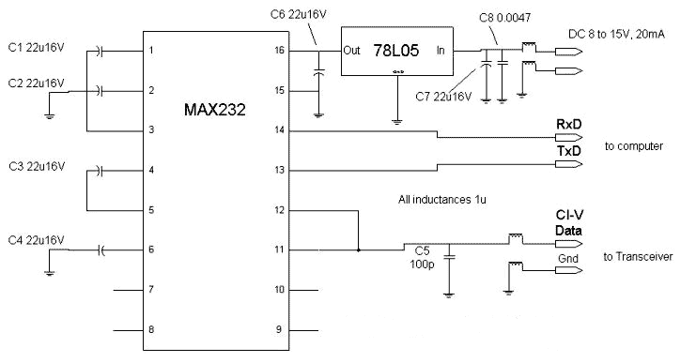
To be honest, I was lazy and DIDN'T put in the inductors nor the C7, C8, and C5 bypass caps.
C1, C2, C3, C4 and C6, the MAX232 is all you need -- and all I used.
It works cheap and simple
in fact you can get the MAX232 chip free by asking for a sample from the MAXIM site!
(Don't tell them I sent you)

A 'quick and dirty' interface that doesn't require an external power supply
and one that you can mash into an RS232 connector hood (like Icom sells).
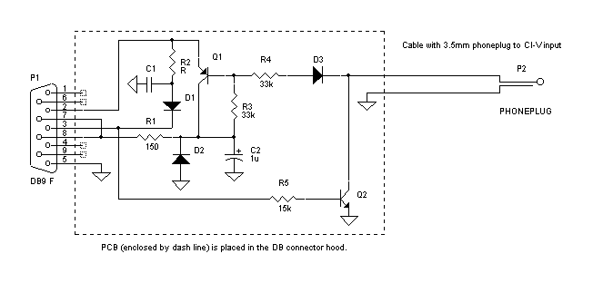
Alexander from Russia writes:
Concerning schematic for CI-V adapter. I drew down it from real PCB so I specified part value for readable components only. They all are smd.
C1 - ceramic (looks strange but it's true),
R5 - at least 0.5W
Q1 and Q2 I guess can be any switch transistors.
I checked this adapter with CI-V Explorer software, everything's ok.

2720 Navigation links
 |   Top of Form  Bottom of Form
 |  | 18 Jul 2004 @ 22:30:18 UTC | Not logged in. Log In

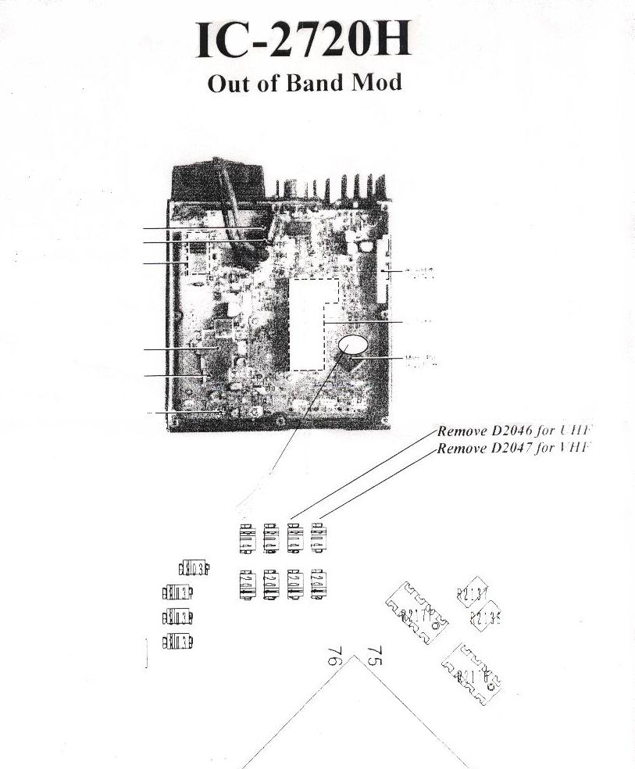
COM IC-2720H MARS/CAP mod

To modify the IC-2720H for extended xmit (MARS/CAP), remove the two diodes shown in the drawing and picture.
The drawing shows a cluster of 8 miniature diodes and which two to remove.

My IC-2720H (US version) ONLY HAD THESE TWO DIODES INSTALLED. The other 6 shown in the drawing were already removed.
I took a picture of the area before I removed the two diodes.

As you can see in the picture, they are the only two installed in that 8 cluster area, remove them both.

Extended transmit freqs after removal are:

VHF: 136.000 - 173.995
UHF: 400.000 - 469.975

I removed the two diodes and powered up the radio WITHOUT reseting and the extended xmit was available without loosing any memories.

cheers

