IC-2720H Extended TX/RX Mod
U.S.A. Users Please note!
Modifications of FCC Type Accepted Radios for Amateur Service are NOT authorized
for use on other bands (particularly FRS, Marine, Business, etc) -- Modifications to Amateur Radios for use on MARS/CAP bands are for Authorized Users only (Licensed by the appropriate service).
The mods shown on this page are for Amateur information purposes only.
Only make modifications at your OWN RISK. Do not transmit outside the limits of your FCC License authorization. Modifications made to your Icom radio WILL VOID YOUR WARRANTY. (and you may screw it up!)
PLEASE Do Not 'Trash' other radio services/bands with modified Amateur Radios!
These mods are NOT guaranteed to work with your particular model.
To modify the IC-2720H for extended xmit (MARS/CAP),
remove the two diodes shown in the drawing and picture
The Extended Transmit Freqs After the Mod are :
VHF: 136.000 - 173.995
UHF: 400.000 - 469.975
The Receive Frequencies should be:
118.0 MHz - 549.95 MHz (L & R)
810.0 MHz - 999.990 MHz * (R)
*U.S.A. Note:
The 824.005 to 848.995 and 869.005 to 893.995 MHz ranges are inhibited on the U.S. models in compliance with US law and the Electronic Privacy Act.
Monitoring cell phone frequencies is illegal in the U.S. In order for any radio to be sold in the U.S. (and receive FCC approval), it cannot be able to be 'moded' to receive those frequencies.
And YES it will receive fine on 220MHz amateur band, but will NOT transmit there.
This drawing shows a cluster of 8 miniature diodes and which two to remove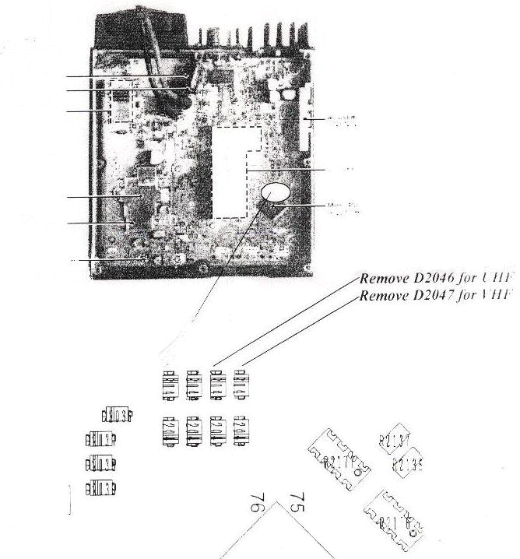
My IC-2720H (US version) ONLY HAD THESE TWO DIODES INSTALLED.
The other 6 shown in the drawing were already removed.
Note: Some US models have a third Diode Installed - D2045
This INHIBITS the Cross-band repeater function - Remove to enable it
I removed the diodes and powered up the radio WITHOUT resetting and the extended xmit was available without loosing any memories.
Here is a picture I took of my radio
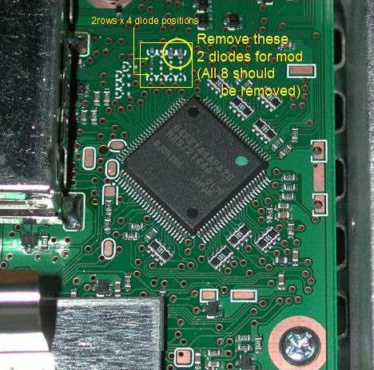
As you can see in the picture, they are the only two installed in that 8 cluster area, remove them both.
If you have a 3rd diode installed, remove this as well -- this will enable your cross-band repeater function
on some models (European, etc) - but shouldn't be necessary on US models.
The modification is simple - just be careful with your soldering iron, the jumpers are small SMT parts, you will need tweezers to pull them off, or if you are a barbarian like me, just heat the damn thing up and knock it off the board with the end of needle nose pliers or something and then shake if off the board. (others report that they just smashed them with needle-nose pliers - no soldering)
See the note below about opening up the European version (IC-2725E)with SOFTKEYS and not diode mods. (please note, I don't have a IC-2725E and so, haven't tried the softkey thing, so I really don't know if it works - I am just relaying the info)
European IC-2725E Receive Notes
(this will not work with the US IC-2720)
I have IC-2725E. This model covers 144-146 MHz and 430-440 MHz RX and TX "out of the box". But when you power on the radio with DUP/MONI and LOW/PRIO button pressed (no internal modification needed) you will expand the RX range (TX stays the same)to the following numbers:
left side: 118.000-549.995 MHz
right side: 118.000-173.995, 375.000-549.995, 810.000-999.990 MHz
The are no gaps within these bands. I can not tell anything about sensitivity within 800-999 MHz as I do not have a proper antenna and there is no "analog-FM" activity within this band in my area except GSM phones (880-911/935-956) which use 200kHz channel spacing digital mode transmission.
Regards,Pawel, SP7XFT

2720 Navigation links

