

Mods for IC-2725
Expanded TX/RX for IC-2720/D/H and IC-2725E
Expanded TX/RX for several nationalities. Download the PDF file
Use the Adobe Acrobat Reader click on the link if you don't have this program
Reducing the RFI on microphone PTT line

While working on 2m band and high power, when the microphone is held too close to the antenna, the PTT 'hangs' in TX mode when going over to RX and/or there is sometimes no modulation during TX.
This is due to RFI on the PTT line going into the display/controller unit, and can be particularly annoying when working mobile with an antenna affixed to the front windshield (like PROCOM 'Glassfix' dualbander).
Solution :
RFI can be drastically reduced by inserting a 10 to 22nF capacitor between PTT line and ground (scratch a little bit of the PCB varnish), on the RJ-45 plug in the controller unit. See picture. If SMD capacitor not available, then try with a chip capacitor, solder the 'ground' side on big solder pad (solder of the potentiometer casing).
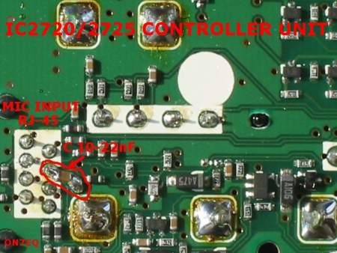
best 73s
Jean-Jacques - ON7EQ

IC-2725 Cross band Repeat Mod

If you remove all 4 diodes on the Icom IC2725, it enables the Cross Band Repeater function as well as Expanded TX.
The Cross Band Repeat function is operated in the same was as the IC2720.
73's
Allan - MM1BJP

IC-2725 tx expand

Look at the mod for the ic2720 the pic of the pcb board is the same as for the ic2725.
The IC-2725 has 4 diodes fitted just remove the two in the pic dont know what happens if you remove the other two.
I have tried this mod on my ic-2725 and it works fine and when you do a reset you do not have to push in the buttons for the wide tx hi...
Coverage is now TX
400 MHz to 469.999 MHz
136 MHz to 173.999 MHz

Icom IC 2725 RX expand

- 1- Turn off
- 2- Press and Hold "DUP" + "LOW"
- 3- Switch on
Now check the bands you have available 118mhz - 900 mhz

ATTENTION
The KB2LJJ takes no responsibility for any damage during the modification or for any wrong information made on this modification.

