APRS and Packet Radio

The ICOM IC-2720H does an excellent job of supporting APRS / Packet and voice simultaneously with its dual band capability.
Tom Webb, WA9AFM/5 Provides these tips on using your IC-2720 for APRS and Packet:
It is possible to run APRS / Packet and voice with the 2720.
The 'left' panel needs to be selected as 'main' band,
You must select the 'right' side of the panel for packet (Initial Set Mode actions, see page 62 in manual);
this will force packet to the 'sub' band on the right.
voice operations will be on the 'main band' on the 'left'.

Set the packet speed for 9600 baud (see page 69 in manual). This will accomplish three things;
The mike will be muted during packet transmissions and thus, you won't have to unplug it.
During voice operations, data transmission will be suppressed and voice will have priority;
Flashing 'S1' will appear in the lower right corner when transmitting on voice.
**NOTE: you can still run 1200 baud packet -- the 9600 baud setting enables the 'dual mode' option.

I use the Byonics TinyTrakIII. (but this should follow for other TNC's)
Using the mini-DIN 6-pin connector, the cable doesn't require data out
(* you will need to use Data out for 9600 baud or the AF out for 1200 baud -
there are two audio outputs -- choose the one for your baud rate *)
PIN | SIGNAL | 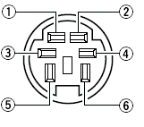  FRONT PANEL VIEW
1* | Data in (audio in) *see page 62
2 | Ground
3 | PTT
4 | Data Out - 9600 Baud Only
5 | AF Out - 1200 Baud Only
6 | PSQL (carrier detect)

If the TTIII is powered up before the 2720 the yellow CD light will come on steady.
When the 2720 is powered up, the CD light will go off and only come on when a signal is detected.

You will get de-sensing on voice from the APRS transmissions, but it's a fair tradeoff as you're using one radio and antenna. I've been using this configuration for several weeks with great success
* See p. 62 for details on how to toggle data speed between 1200 (AFSK) and 9600 bps (G3RUH, GMSK).

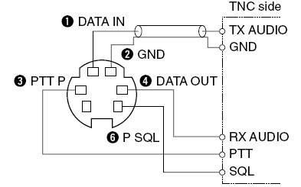 | 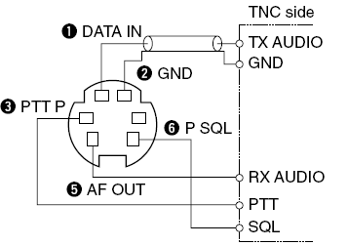
Connections for 9600 Baud | Connections for 1200 Baud
Thanks to Tom, WA9AFM for these tips
2720 Navigation links

